|  |  |
| --- | --- |
| [LAB TASK NO-01] | |
| [KABEER AHMED( SE-28)] |

START

**PROBLEM 1:** Write an algorithm and draw the flowchart for finding the average of two numbers.

**Algorithm:**

Input: two numbers x and y

Output: the average of x and y

**FLOWCHART:**

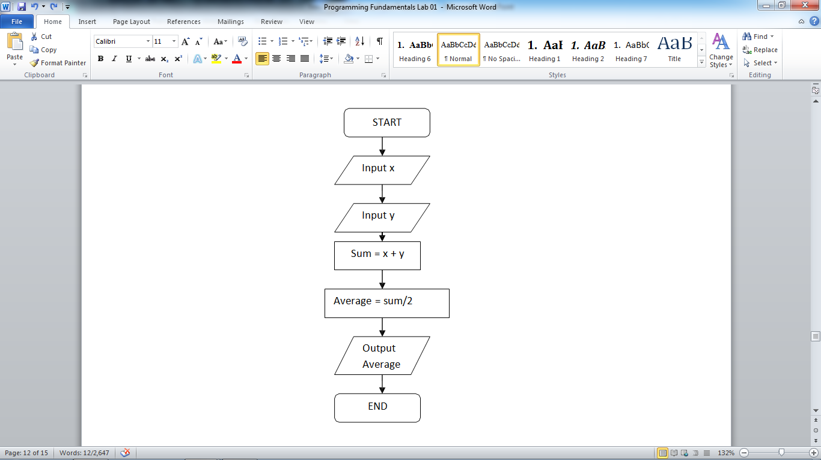

**Problem 2:** Write an algorithm for finding the area of a rectangle.

**Algorithm:**

• define the inputs and the outputs

• define the steps

• draw the flowchart

**PROBLEM 3:** Write a program that asks the user to enter their name and their age. Print out a message addressed to them that tells them the year that they will turn 100 years old.

**INPUT:**

nam=input(**"Enter Your Name"**)  
age=int(input(**"Enter Your Age"**))  
year=(2019-age)+100  
print(nam,**"will be 100 Years Old in "**,year)

**OUTPUT:**

Enter Your Name**Kabeer**

Enter Your Age**18**

Kabeer will be 100 Years Old in 2101

**PROBLEM 4:** Write a Python program to print the following string in a specific format.

**INPUT:**

print(**"Twinkle, twinkle, little star, \n\tHow I wonder what you are! \n\t\tUp above the world so high, \n\t\tLike a diamond in the sky. \nTwinkle, twinkle, little star, \n\tHow I wonder what you are!"**)

**OUTPUT:**

Twinkle, twinkle, little star,

How I wonder what you are!

Up above the world so high,

Like a diamond in the sky.

Twinkle, twinkle, little star,

How I wonder what you are!

**PROBLEM 5:** Write a Python program to display the current date and time.

**INPUT:**

**import** datetime  
now=datetime.datetime.now()  
print(**"The Current Time is "**,now.strftime(**"%Y-%m-%d"**))  
print(**"The Current Date is "**,now.strftime(**"%H:%M:%S"**))

**OUTPUT:**

The Current Time is 2019-11-05

The Current Date is 22:08:24

**PROBLEM 6:** Write a Python program which accepts the radius of a circle from the user and compute the area.

**INPUT:**

**from** math **import**\*  
r=float(input(**"Enter Radius of circle"**))  
a=pi*r**2  
print(**"The Area of Circle is"**,a)

**OUTPUT:**

Enter Radius of circle**4.5**

The Area of Circle is 63.61725123519331

**PROBLEM 7:** Write a Python program which accepts the user's first and last name and print them in reverse order with a space between them.

**INPUT:**

fname=input(**"Enter Your First Name"**)  
lname=input(**"Enter Your Last Name"**)  
print(**"Hello "**+lname+**"\t"**+fname)

**OUTPUT:**

Enter Your First Name**Kabeer**

Enter Your Last Name**Ahmed**

Hello Ahmed Kabeer

**PROBLEM 8**: Write a Python program to print the calendar of a given month and year.

**INPUT:**

**import** calendar   
 y=int(input(**"Enter The Year"**))   
 m=int(input(**"Enter The Month"**))   
 print(calendar.month(y,m) )

**OUTPUT:**

Enter The Year**2019**

Enter The Month**11**

November 2019

Mo Tu We Th Fr Sa Su

1 2 3

4 5 6 7 8 9 10

11 12 13 14 15 16 17

18 19 20 21 22 23 24

25 26 27 28 29 30

**PROGRAMMING EXERCISE**

**1. Write a program for converting Degree Centigrade to Fahrenheit**

**INPUT:**

c=int(input(**"Enter The Temp in Centigrade"**))  
f=(c*9/5)+32  
print(**"Temp in Fahrenheit is"**,f)

**OUTPUT:**

Enter The Temp in Centigrade**100**

Temp in Fahrenheit is 212.0

**FLOWCHART:**

**2. Write a program for converting Degree Fahrenheit to Centigrade.**

***START***

***Output***

***Fahrenheit(F)***

**F=(C*9/5)+32**

***Input***

***Centigrade(C) )***

***END***

**INPUT:**

f=int(input(**"Enter The Temp in Fahrenheit"**))  
c=(f-32)*5/9  
print(**"Temp in Centigrade is"**,c)

**OUTPUT:**

Enter The Temp in Fahrenheit**212**

Temp in Centigrade is 100.0

**FLOWCHART:**

***START***

***Output***

***Centigrade(C)***

**C=(F-32)*5/9**

***Input***

***Fahrenheit(F) )***

***END***

**3. Write a program to calculate the area of rectangle.**

**INPUT:**

len=float(input(**"Enter The Length Of Rectangle"**))  
wid=float(input(**"Enter The Width Of Rectangle"**))  
area=len*wid  
print(**"The Area of Rectangle is "**,round(area,2))

**OUTPUT:**

Enter The Length Of Rectangle**8.4**

Enter The Width Of Rectangle**4.5**

The Area of Rectangle is 37.8

**FLOWCHART:**

***START***

***Output***

***Area***

**Area=Length*Width**

***Input***

***Length***

***END***

***Input***

***Width***

**4. Write a program to calculate the volume of a sphere.**

**INPUT:**

**from** math **import**\*  
r=float(input(**"Enter The Radius Of Sphere"**))  
v=(4/3)*pi*(r**3)  
print(**"The Volume Of Sphere is "**,round(v,2))

**OUTPUT:**

Enter The Radius Of Sphere**33.4**

The Volume Of Sphere is 156073.08

***START***

***Output***

***Volume(V)***

**V=(4/3)*pi*R**3**

***Input***

***Radius(R)***

***END***

**5. Write a program that can write your name is upper case, lower case, and title case.**

**INPUT:**

a=input(**"Enter Your Name"**)  
print(a.upper())  
print(a.lower())  
print(a.title())

**OUTPUT:**

Enter Your Name**KABEER ahmed**

KABEER AHMED

kabeer ahmed

Kabeer Ahmed

**FLOWCHART:**

***START***

***Output NAME***

**UPPER=Name.upper()**

***Input Name***

***END***

**LOWER=Name.lower()**

**TITLE=Name.title()**

***Output name***

***Output Name***